**Arduino Repeat Project**

**Christopher Kelly**

**S00170485**

**Introduction**

My project is a simple idea to help rule out human error in what is known as “The Beep Test” in secondary schools across Ireland.

**Background**

In secondary school, every person who participates in P.E. must, at some point, participate in a Beep Test. This is a test of physical endurance where students run from one end of the hall to another while an audible beep is played in the background which increases in speed with every level. Students must reach the other end of the hall before the beep sounds. If a student fails to do so 3 times, they take a seat and wait until the last student can no longer continue. While participating in this for several years I noticed there is a glaring problem with this test which has never been addressed. Students who participate and maybe do not make the line before the beep has sounded can get away with it due to many reasons such as the position the coach is standing. If the coach is standing in the middle of the hall, the angle at which he is looking at the students can lead to not quite accurate results. My project aims to eliminate this with also having added side benefits.

**Functionality**

As of now my project is a simple. Touch the sensor and the Arduino buzzer emits a sound and a LED will flash. There is also a timer as to stop the buzzer after 1 second. This eliminates all human error because if the student has not pressed the Touch Sensor before the buzzer has sounded it will be obvious. An added benefit to this is when the student pushes the button it can send a time to a google spreadsheet of the student’s time since he pushed the last one which can be used to track his/her performance. Unfortunately, I was not able to work this functionality.

**Implementation**

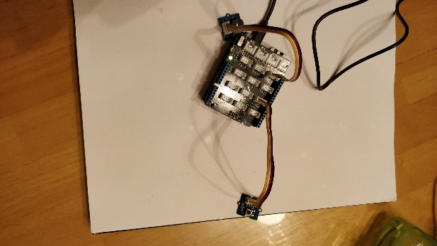

As of right now my design is simple. It is a simple Touch Sensor plugged into port 2 with a buzzer plugged into port 4 and the onboard LED. I have included a link to my GitHub where I organized my code below.

**Project Management**

The idea is simple and while the initial idea was to use a phone or smart watch as well as a sensor/laser as this would be accurate and less set up than having a pad/touch sensor for each student to push. My next idea was to use the button and was initially using this until I realized it would be better to use the touch sensor as it would be easier for the students. A light tap and it would register the input as opposed to pressing a button which may not seem much different but when you are calculating you time in milliseconds to review your performance it can make the difference. Another change which was made was the added functionality of a delay after the sensor is pressed which I never originally thought of but as it was pointed out to me, children being children will abse the power of the buzzer and keep pressing it. The implementation of the main idea did not take long as it was simple. The part of the project I spent a considerable amount of time on was getting the google spreadsheet to work but I failed to do so as explained later.

**Problems Encountered**

To reiterate the only problem I encountered was trying to link the Arduino to the internet. First, I thought of using a phone but this would include creating an app to do so. I then switched to the idea of a google spreadsheet which could log the results of every person and their history. While I did stick with this idea and tried to implement it into my idea I was unsuccessful. I went through the process of creating the google spreadsheet and Temboo account. I then tried to implement the Temboo code into my project but could not get it to function.

**Lessons Learnt**

This project helped me learn a few things. Better time management would be the biggest issue which I need to work on. It did help me develop the more creative side of me and to think more outside the box with my ideas to come up with a more unique idea. My programming skills have developed since the start of this project.

**References**

1. <http://www.instructables.com/id/How-control-arduino-board-using-an-android-phone-a/> - Link Phone to Arduino
2. <https://www.twilio.com/blog/2015/02/arduino-wifi-getting-started-arduino-yun.html> - Arduino WI-FI
3. <https://console.developers.google.com/apis/dashboard?project=arduino-project-196916&duration=PT1H> – Google API
4. <https://temboo.com/library/> - Temboo Account
5. <https://temboo.com/arduino/yun/update-google-spreadsheet> - Link Arduino to Temboo to Google Spreadsheet
6. <https://github.com/CrizzyK10/arduino> - Github Code